|  |  |
| --- | --- |
| Activity | Data Type |
| Number of beatings from Wife | Discrete Data |
| Results of rolling a dice | Discrete Data |
| Weight of a person | Continous Data |
| Weight of Gold | Continous Data |
| Distance between two places | Continous Data |
| Length of a leaf | Continous Data |
| Dog's weight | Continous Data |
| Blue Color | Discrete Data |
| Number of kids | Discrete Data |
| Number of tickets in Indian railways | Discrete Data |
| Number of times married | Discrete Data |
| Gender (Male or Female) | Discrete Data |

Q1) Identify the Data type for the Following:

Q2) Identify the Data types, which were among the following

Nominal, Ordinal, Interval, Ratio.

|  |  |
| --- | --- |
| Data | Data Type |
| Gender | Nominal |
| High School Class Ranking | Ordinal |
| Celsius Temperature | Interval Scale |
| Weight | Ratio |
| Hair Color | Nominal |
| Socioeconomic Status | Nominal |
| Fahrenheit Temperature | Interval Scale |
| Height | Ratio scale |
| Type of living accommodation | Ordinal |
| Level of Agreement | Ordinal |
| IQ(Intelligence Scale) | Ratio |
| Sales Figures | Interval |
| Blood Group | Nominal |
| Time Of Day | Ratio |
| Time on a Clock with Hands | Ratio |
| Number of Children | Nominal |
| Religious Preference | Nominal |
| Barometer Pressure | ratio |
| SAT Scores | ratio |
| Years of Education | Interval |

Q3) Three Coins are tossed, find the probability that two heads and one tail are obtained?

Answer : When three coins are tossed the total number of possible combinations are 23 = 8.

These combinations are HHH, HHT, HTH, THH, TTH, THT, HTT, TTT.

The number of combinations which have two heads and one tail are:

HHT, HTH, TTH which makes them 3 in number.

Therefore the [Probability](https://www.cuemath.com/data/probability/) of getting two heads and one tails in the toss of three coins simultaneously is defined as:

P(Two heads and One Tail) = Number of desired outcomes

= 3 = 0.375

Q4) Two Dice are rolled, find the probability that sum is

1. Equal to 1
2. Less than or equal to 4
3. Sum is divisible by 2 and 3

Answer : Possible Outcome 6*6=36

1. Equal to 1- 0/36 =0
2. Less than or equal to 4 – 4/36=1/9
3. Sum is divisible by 2 and 3 –

Divisible by 2 and 3 – 29/36

Q5) A bag contains 2 red, 3 green and 2 blue balls. Two balls are drawn at random. What is the probability that none of the balls drawn is blue?

Answer: 10/21

Q6) Calculate the Expected number of candies for a randomly selected child

Below are the probabilities of count of candies for children (ignoring the nature of the child-Generalized view)

|  |  |  |
| --- | --- | --- |
| CHILD | Candies count | Probability |
| A | 1 | 0.015 |
| B | 4 | 0.20 |
| C | 3 | 0.65 |
| D | 5 | 0.005 |
| E | 6 | 0.01 |
| F | 2 | 0.120 |

Child A – probability of having 1 candy = 0.015.

Child B – probability of having 4 candies = 0.20

Answer: 1*0.015+4*0.20+3*0.65+5*0.005+6*0.01+2*0.120

=3.09

Q7) Calculate Mean, Median, Mode, Variance, Standard Deviation, Range & comment about the values / draw inferences, for the given dataset

* For Points,Score,Weight

Find Mean, Median, Mode, Variance, Standard Deviation, and Range and also Comment about the values/ Draw some inferences.

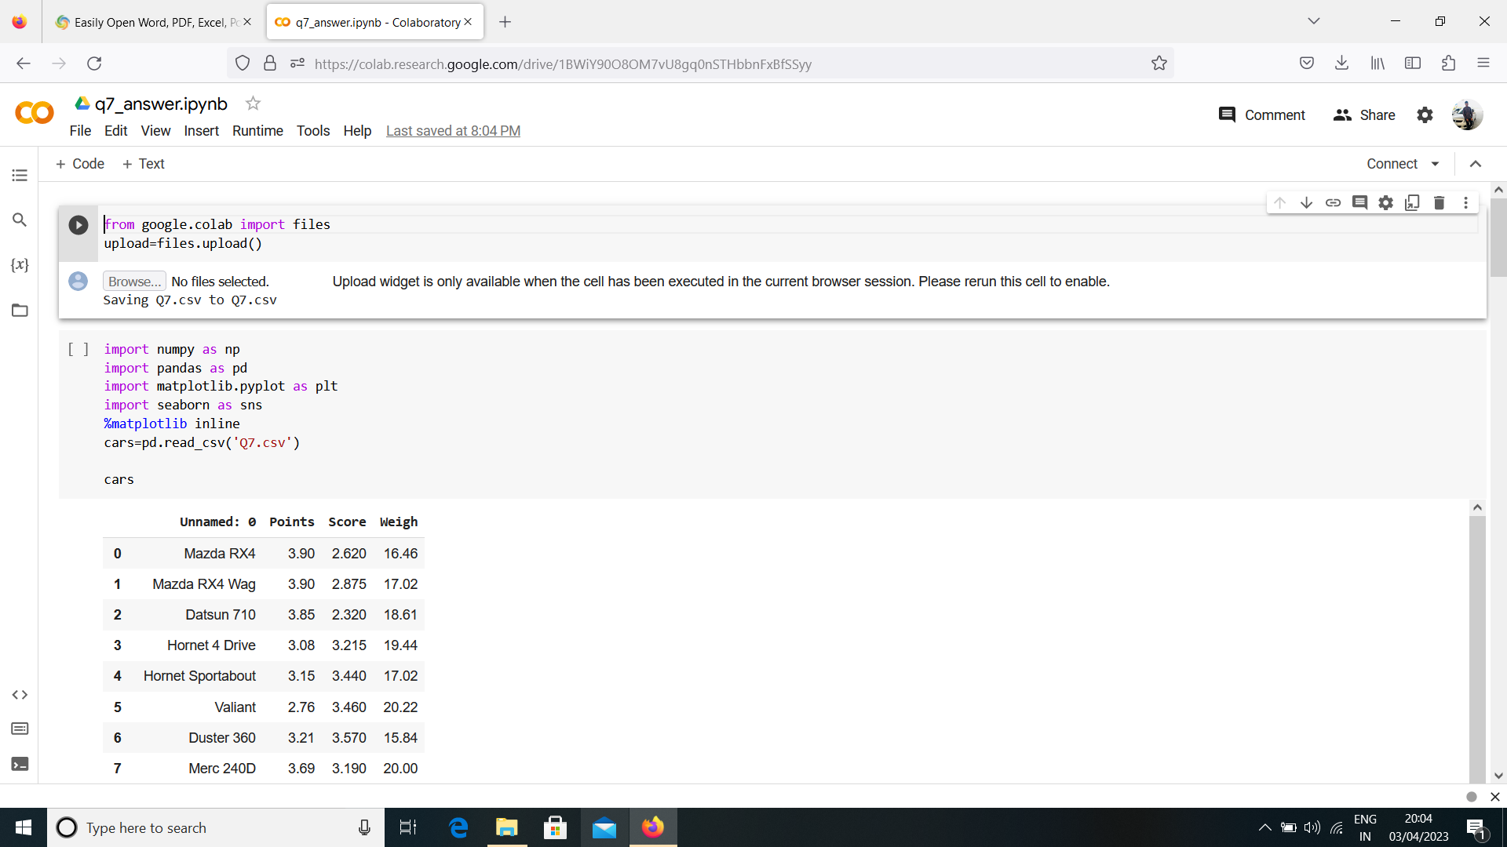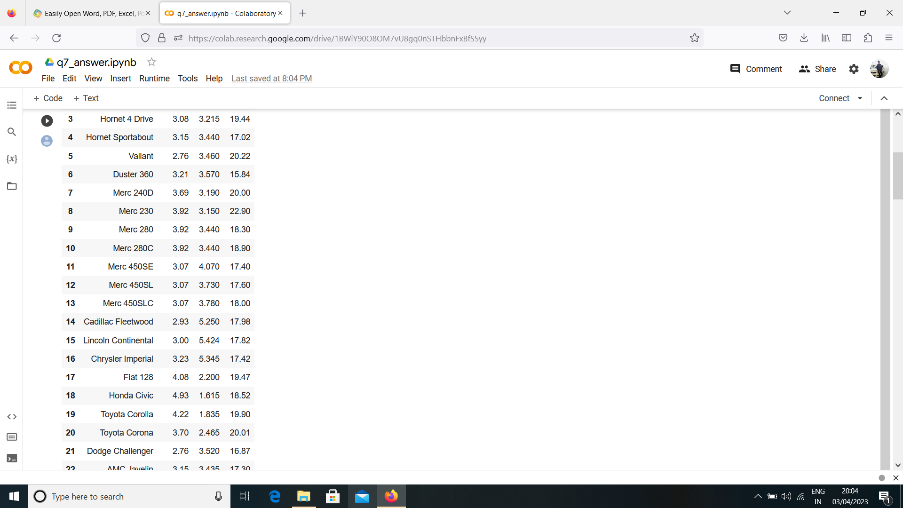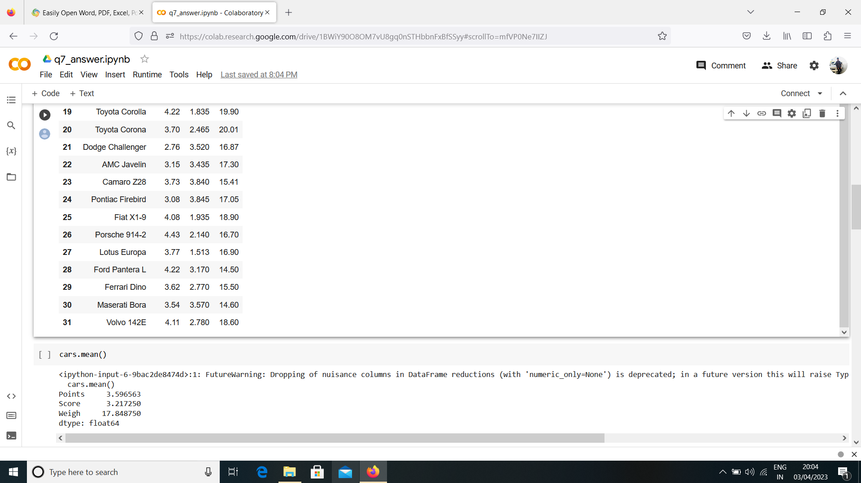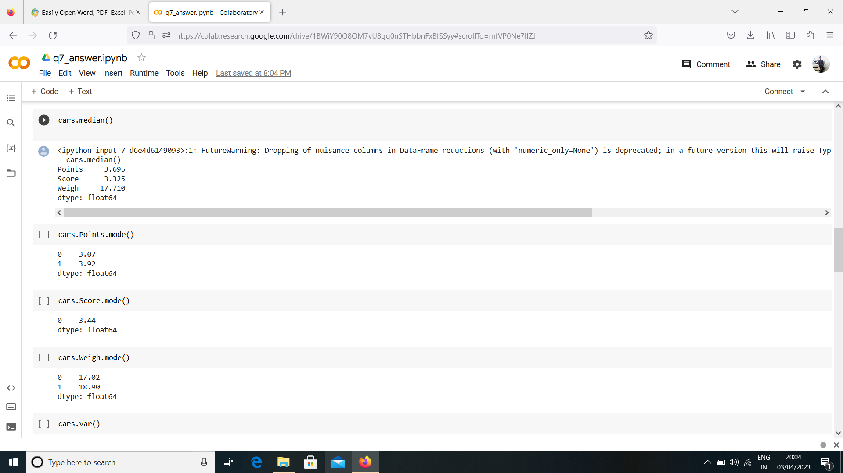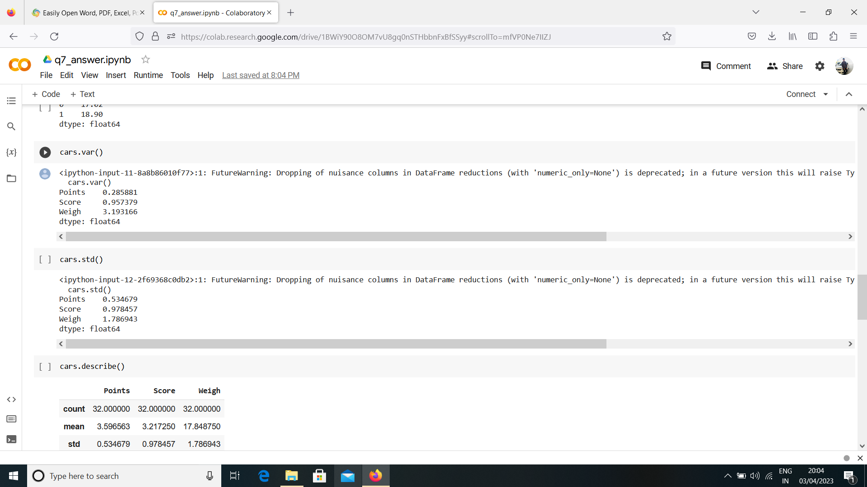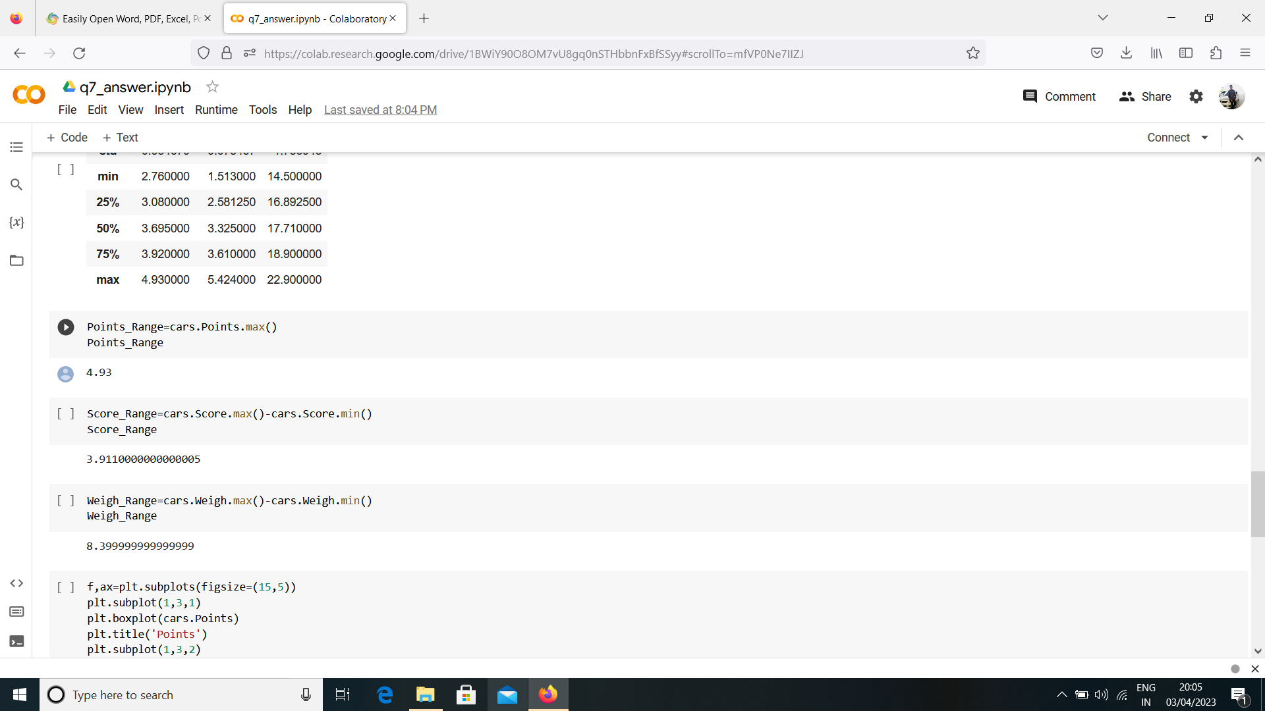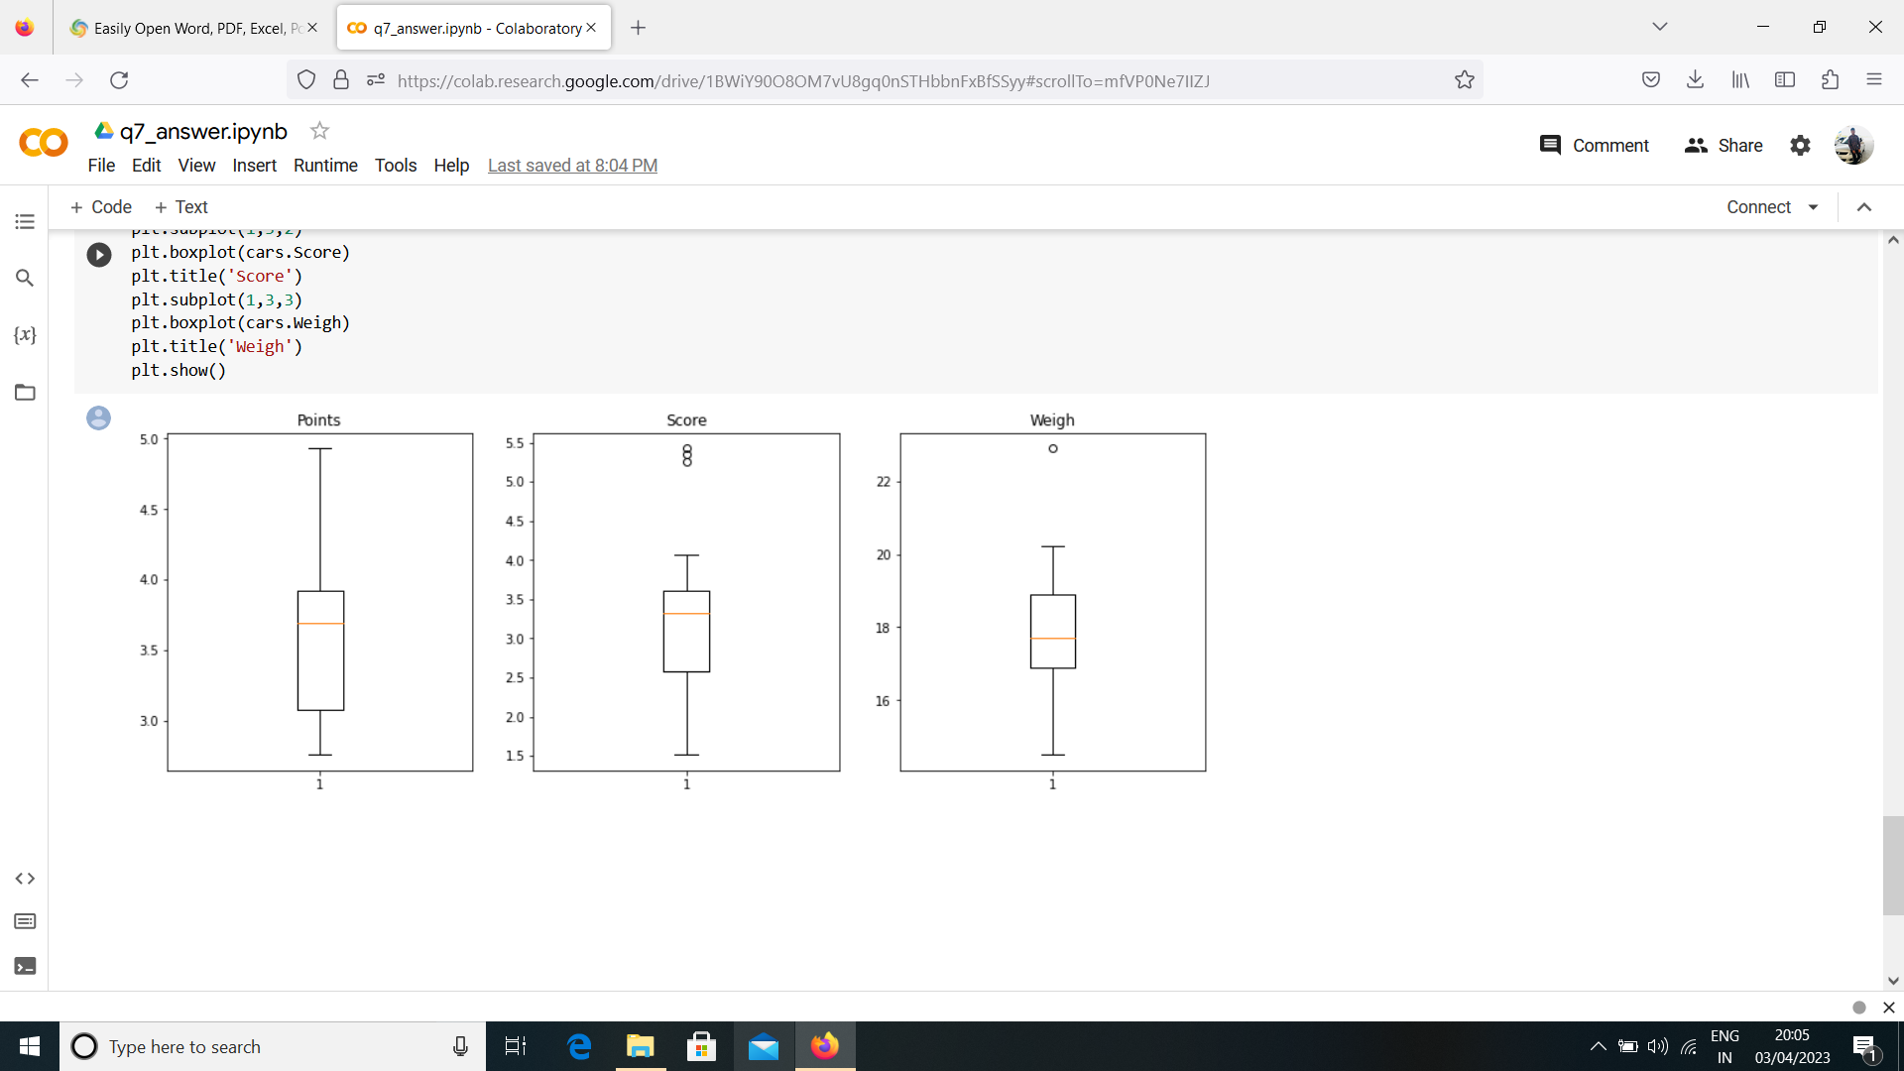

Q8) Calculate Expected Value for the problem below

1. The weights (X) of patients at a clinic (in pounds), are

108, 110, 123, 134, 135, 145, 167, 187, 199

Assume one of the patients is chosen at random. What is the Expected Value of the Weight of that patient?

Answer: =Probability of selecting all patients =1/9

1/9(108+110+123+134+135+145+167+187+199)

=(1/9)(1308)

Expected Value of the weight of that patient=145.33

**Q9) Calculate Skewness, Kurtosis & draw inferences on the following data**

**Cars speed and distance**

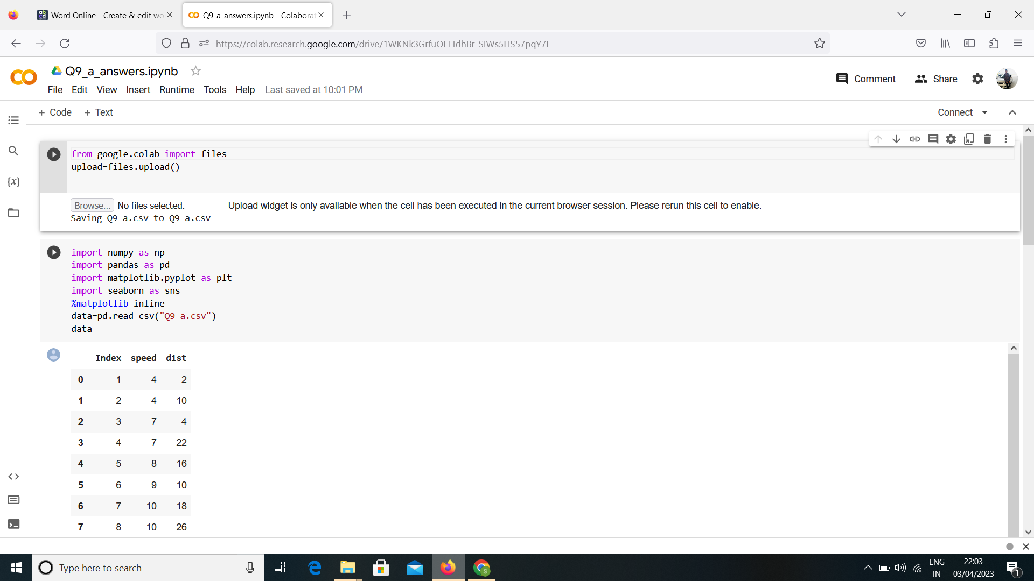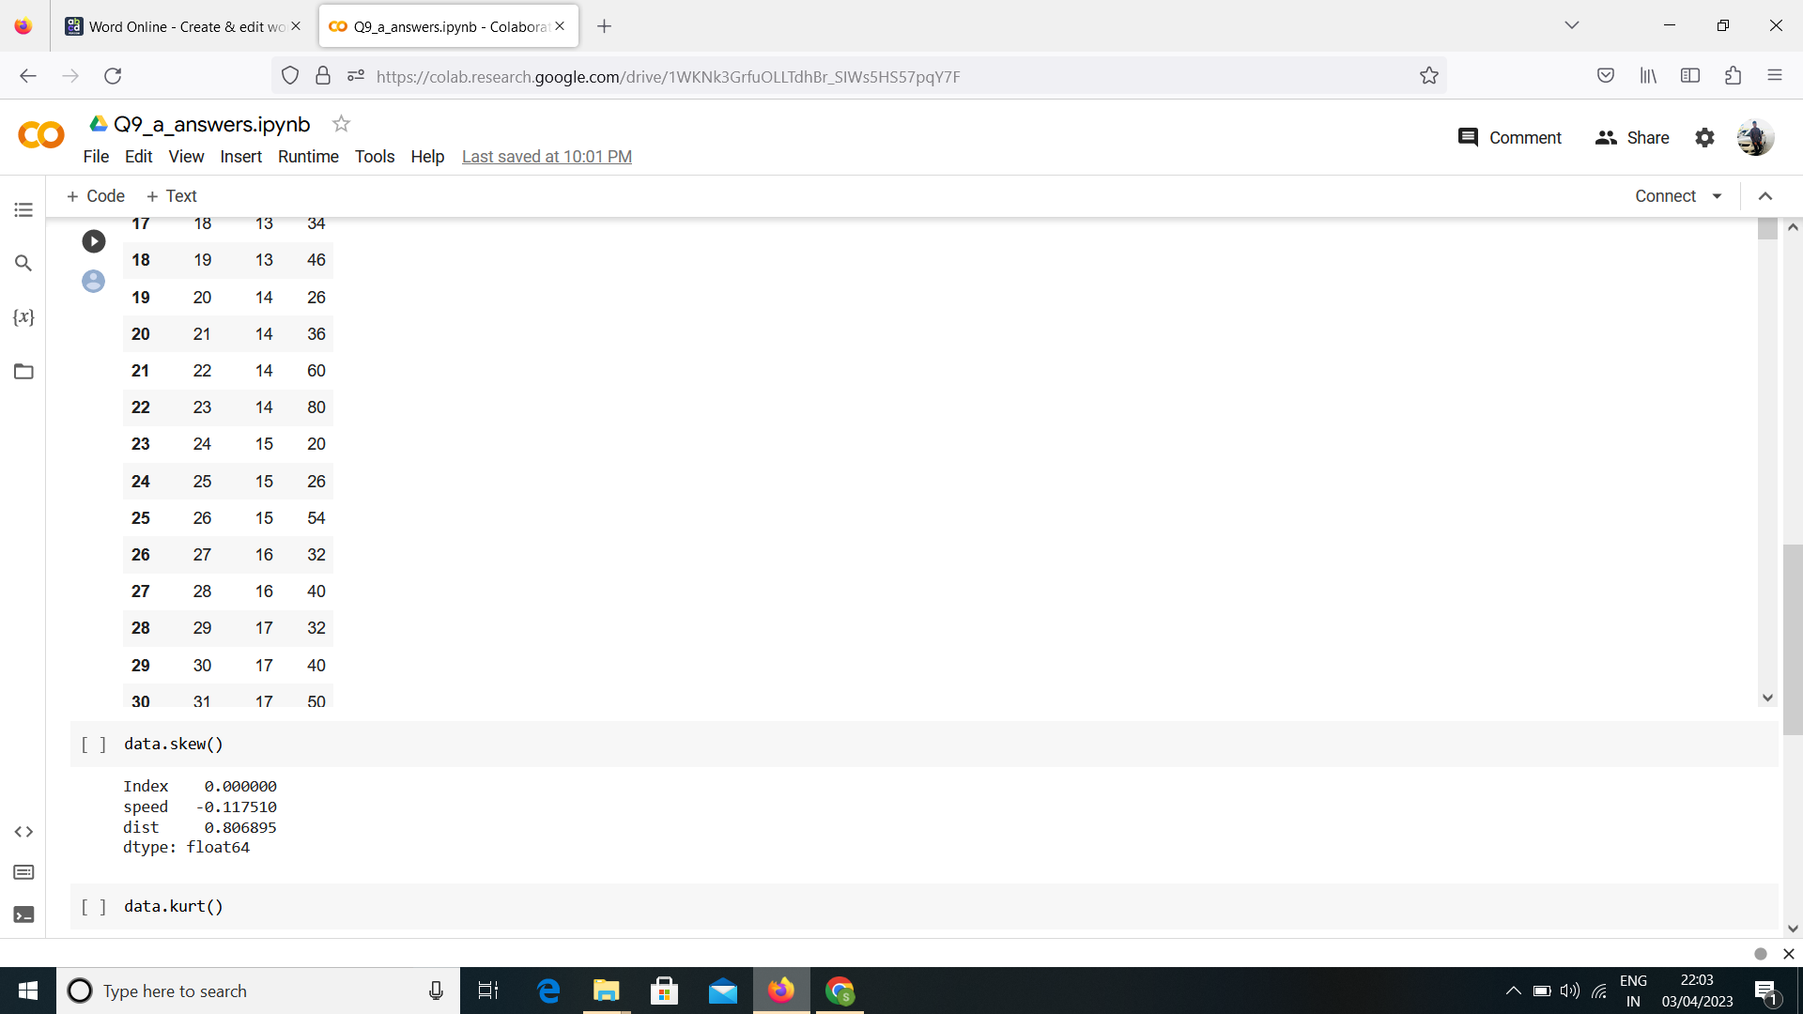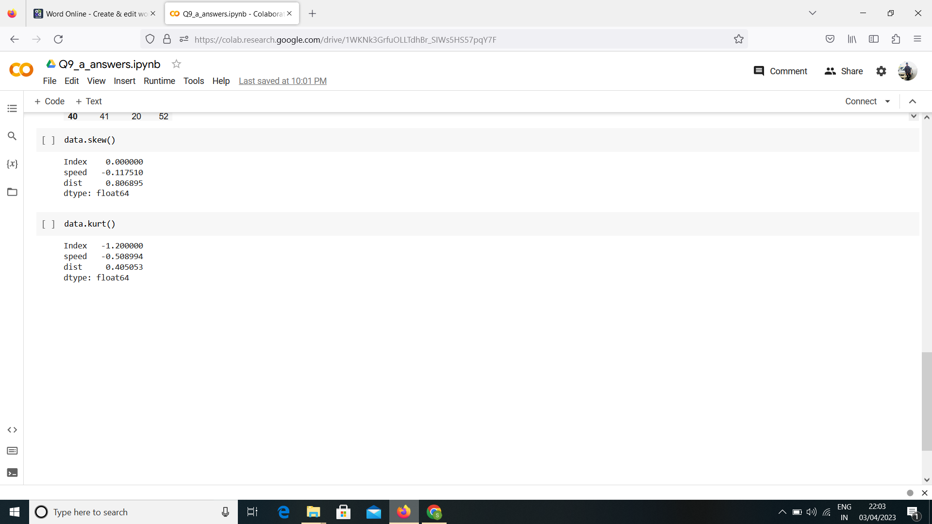

**SP and Weight(WT)**

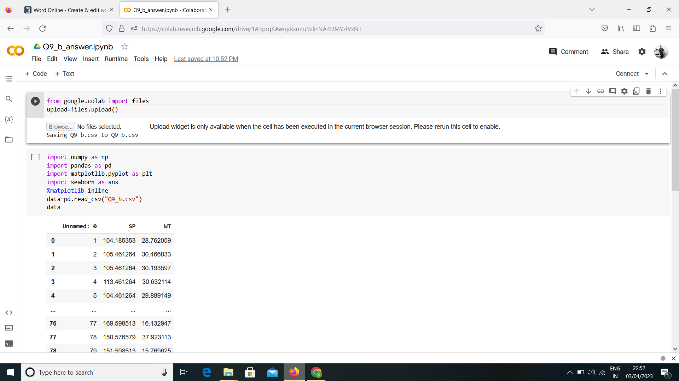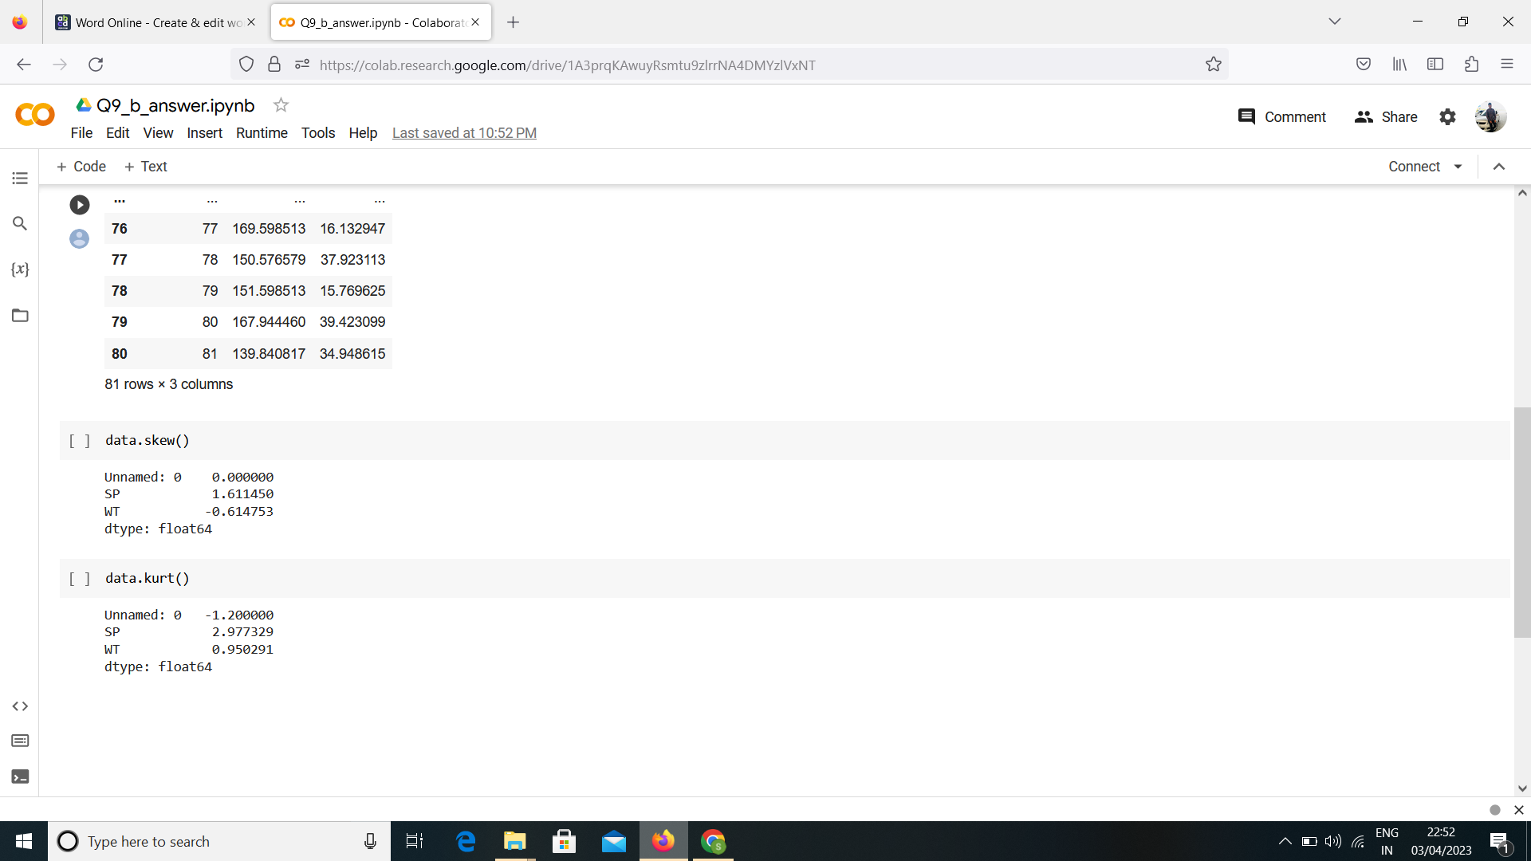

**Q10) Draw inferences about the following boxplot & histogram**

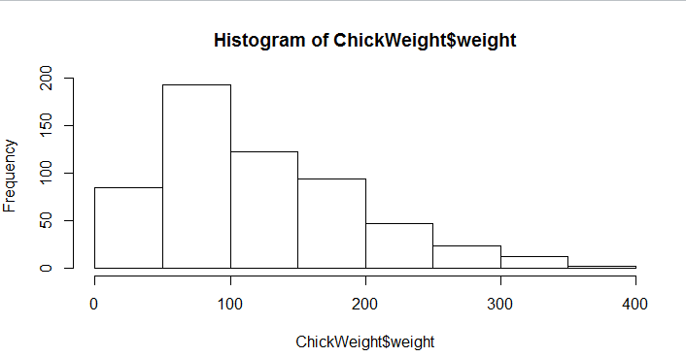

Answer: The histogram peak has right skew and tail is on right. Mean>Medin. We have outliers on the higher side.

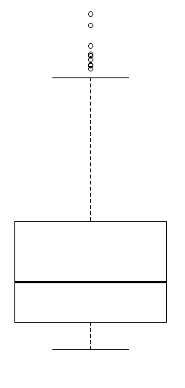

Answer: The Boxplot has outliers on the maximum side.

**Q11)** Suppose we want to estimate the average weight of an adult male in Mexico. We draw a random sample of 2,000 men from a population of 3,000,000 men and weigh them. We find that the average person in our sample weighs 200 pounds, and the standard deviation of the sample is 30 pounds. Calculate 94%,98%,96% confidence interval?

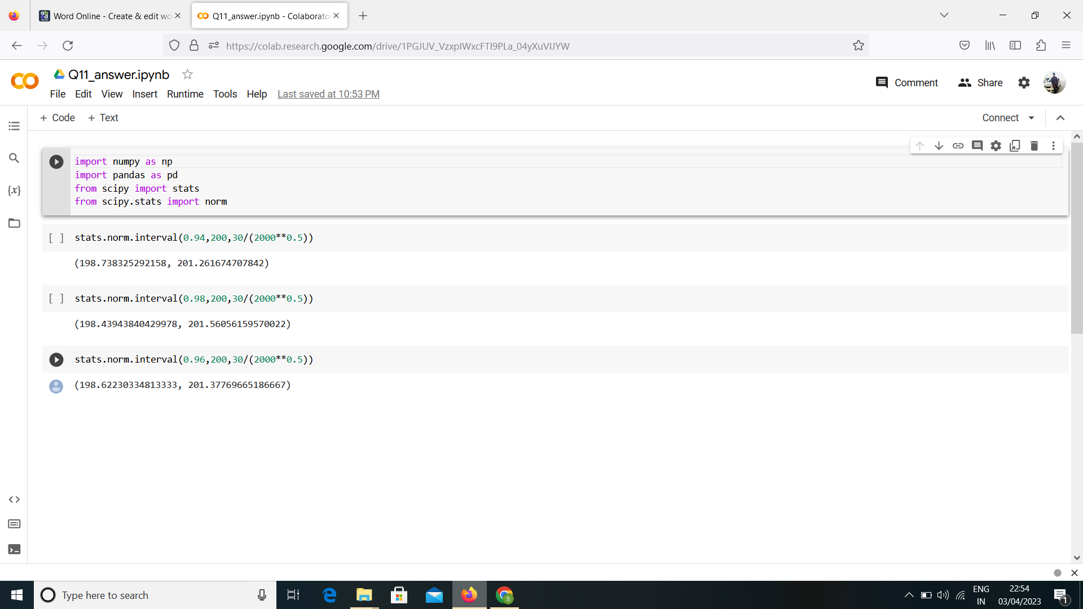

**Q12)** Below are the scores obtained by a student in tests

**34,36,36,38,38,39,39,40,40,41,41,41,41,42,42,45,49,56**

1. Find mean, median, variance, standard deviation.

Ans: Mean=41, Median=40.5, Variance=25.52 and Standarrd deviation=5.05

1. What can we say about the student marks?

Ans: We don’t have outliers and the data is slightly skewed towards right because mean is greater than median.

Q13) What is the nature of skewness when mean, median of data are equal?

Answer: If the mean is equal to the median as well as the mode, hence **the skewness is zero**

Q14) What is the nature of skewness when mean > median ?

Answer: The mean of positively skewed data will be greater than the median

Q15) What is the nature of skewness when median > mean?

Answer: The mean of positively skewed data will be greater than the median

Q16) What does positive kurtosis value indicates for a data ?

Answer: Positive values of kurtosis indicate that distribution is peaked and possesses thick tails.

Q17) What does negative kurtosis value indicates for a data?

Answer: A distribution with a negative kurtosis value indicates that the distribution has lighter tails than the normal distribution.

Q18) Answer the below questions using the below boxplot visualization.

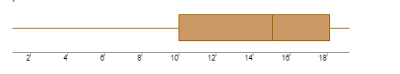

What can we say about the distribution of the data?

Ans: The above Boxplot is not normally distributed the median is towards the higher value.

What is nature of skewness of the data?

Ans: The Data is skewed towards left. The whisker range of minimum value is greater than maximum.

What will be the IQR of the data (approximately)?

Ans: The Inter Quantile Range=Q3 Upper quartile-Q1 Lower Quartile=18-10=8.

Q19) Comment on the below Boxplot visualizations?

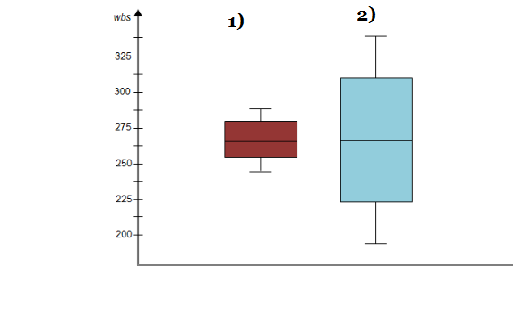

Draw an Inference from the distribution of data for Boxplot 1 with respect Boxplot 2.

Ans:First there are no outliers. Second both the box plot shares the same median that is approximately in range between 275 to 250 and they are normally distributed with zero to no skewness neither at the minimum or maximum whisker range.

Q 20) Calculate probability from the given dataset for the below cases

Data _set: Cars.csv

Calculate the probability of MPG of Cars for the below cases.

MPG <- Cars$MPG

* 1. P(MPG>38)
  2. P(MPG<40)

c. P (20<MPG<50)

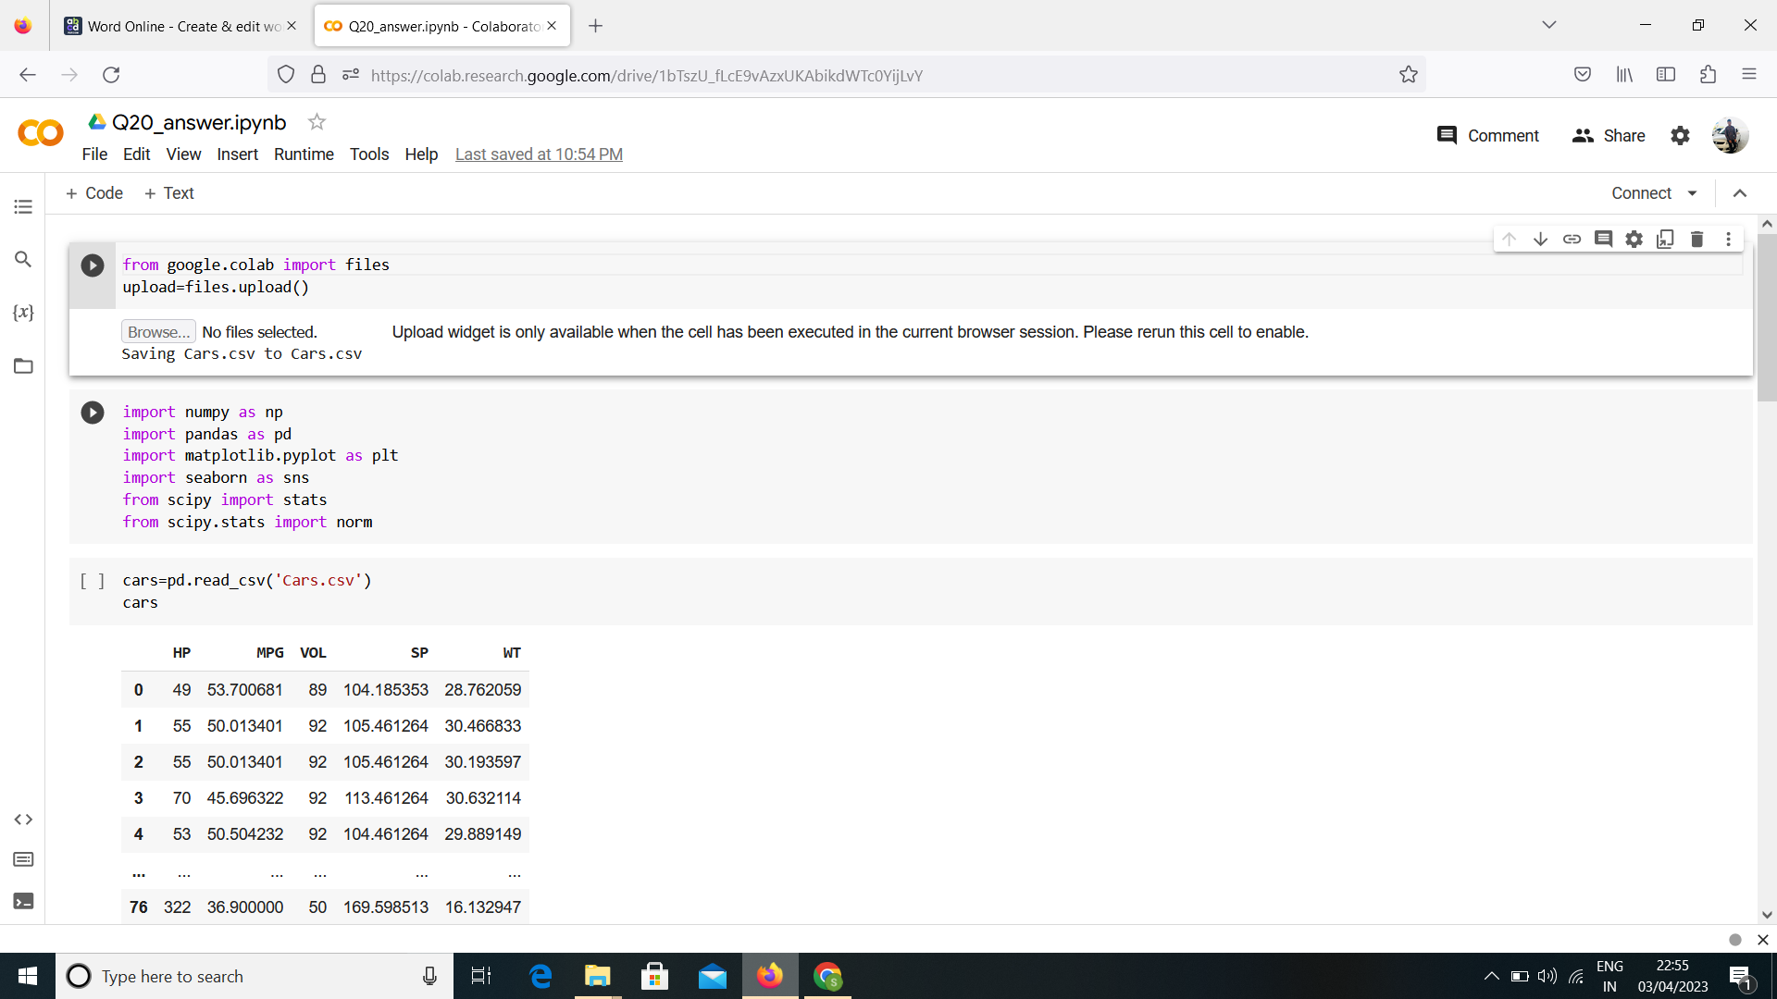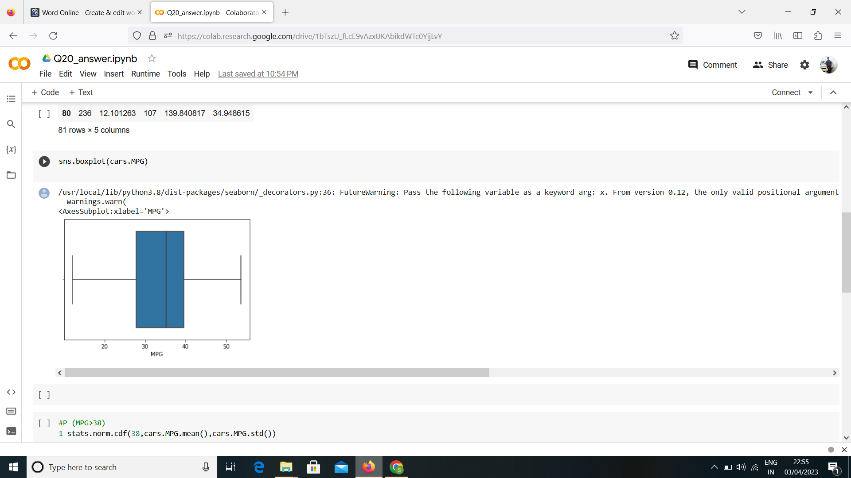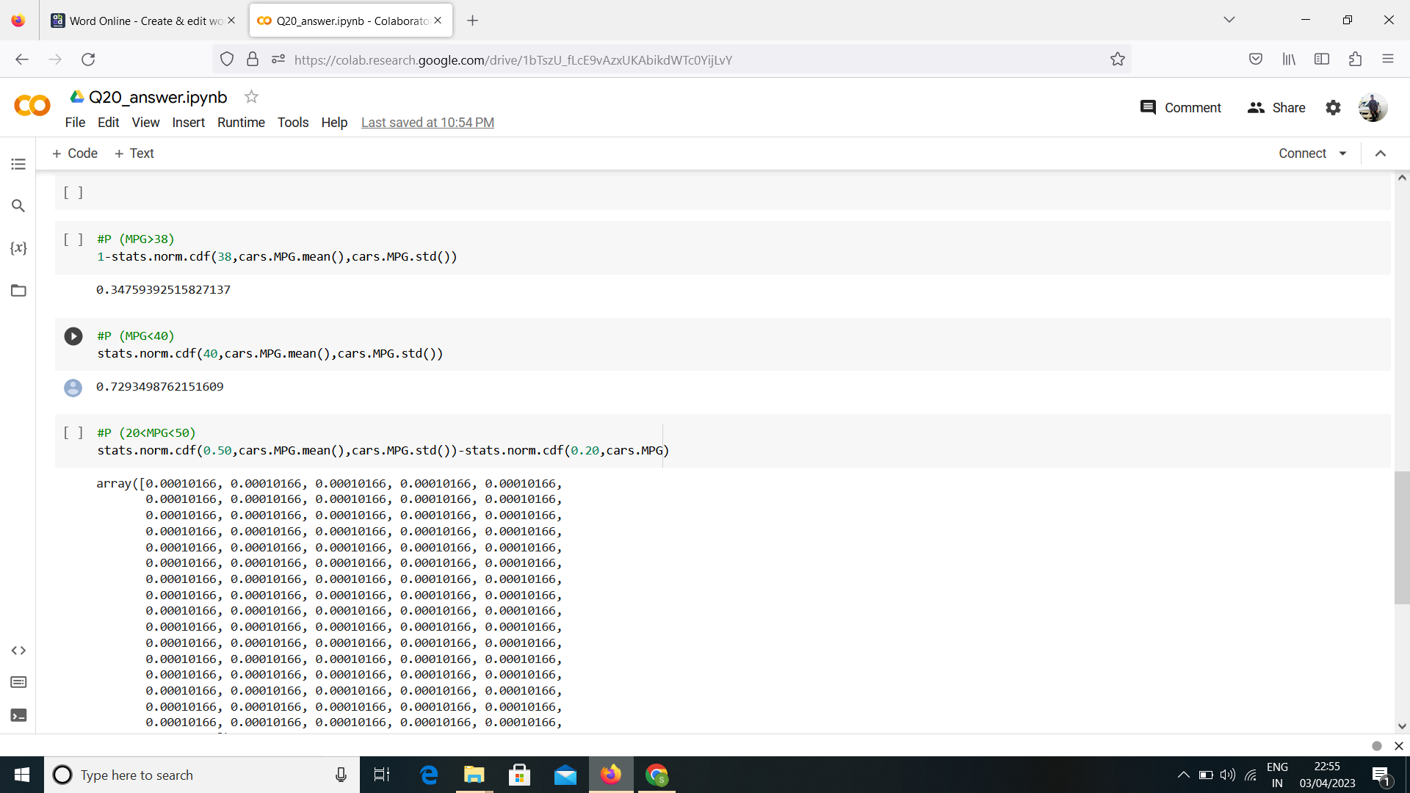

Q 21) Check whether the data follows normal distribution

1. Check whether the MPG of Cars follows Normal Distribution

Dataset: Cars.csv

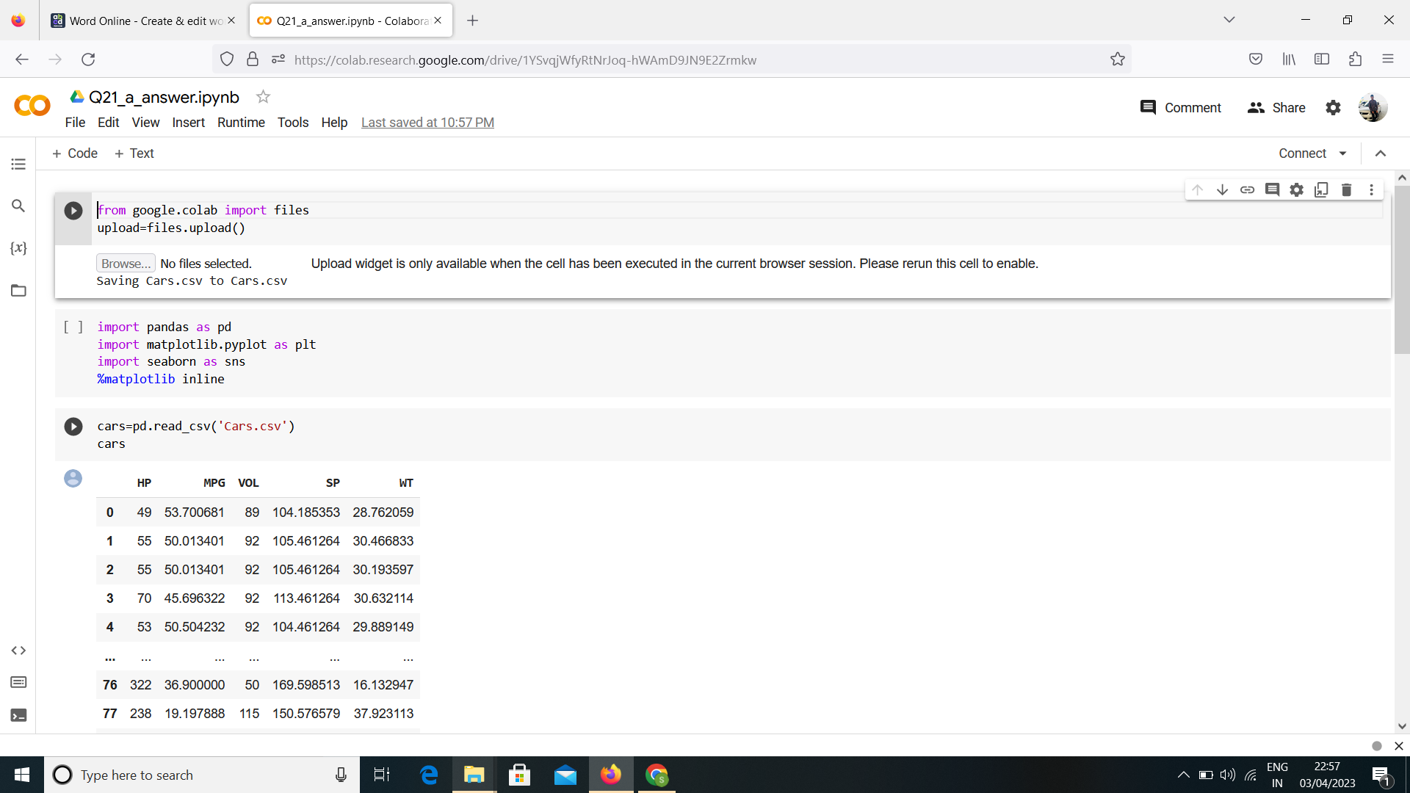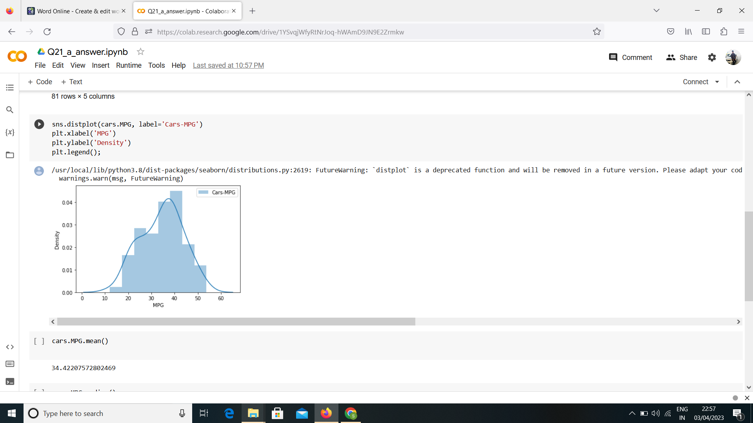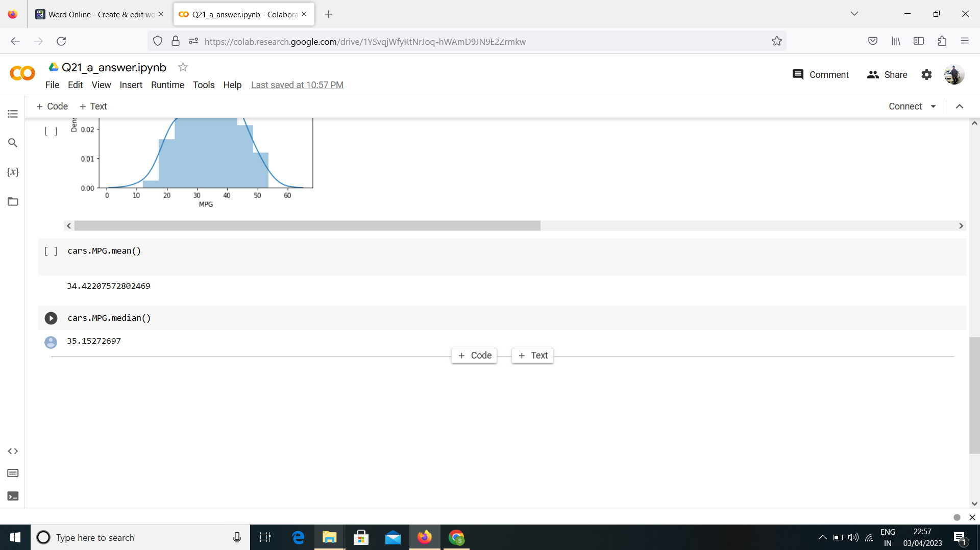

1. Check Whether the Adipose Tissue (AT) and Waist Circumference(Waist) from wc-at data set follows Normal Distribution

Dataset: wc-at.csv

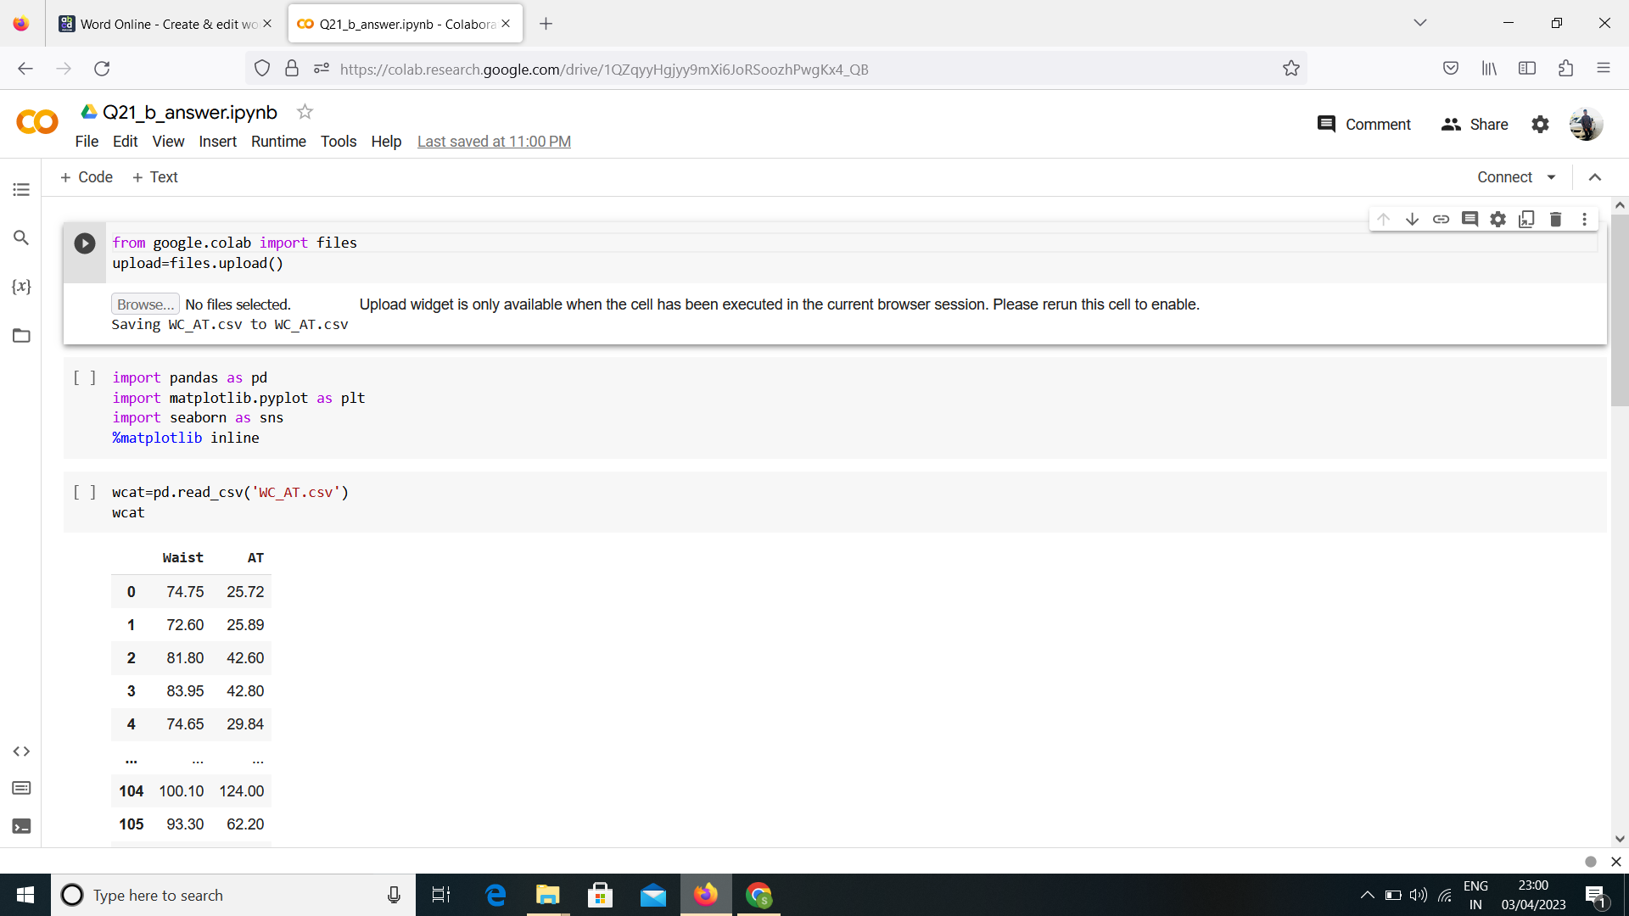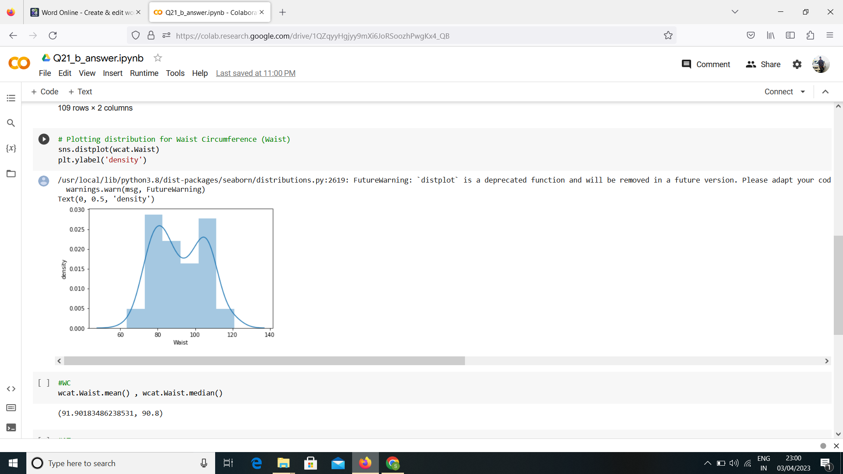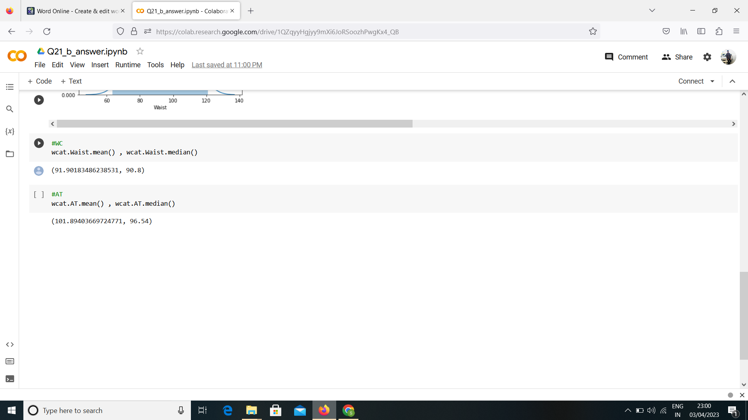

Q 22) Calculate the Z scores of 90% confidence interval,94% confidence interval, 60% confidence interval

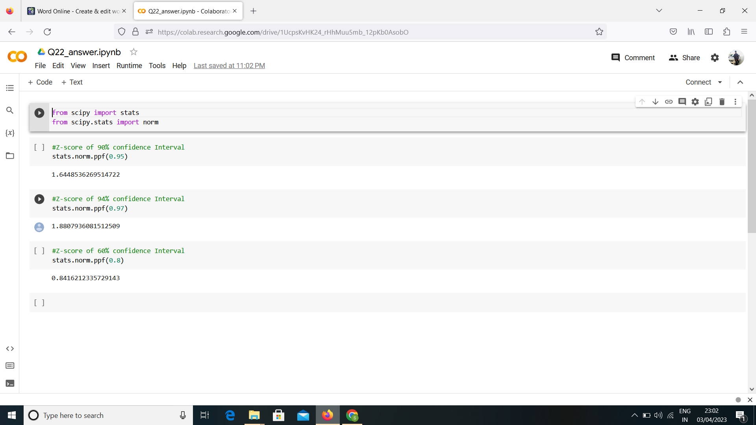

Q 23) Calculate the t scores of 95% confidence interval, 96% confidence interval, 99% confidence interval for sample size of 25

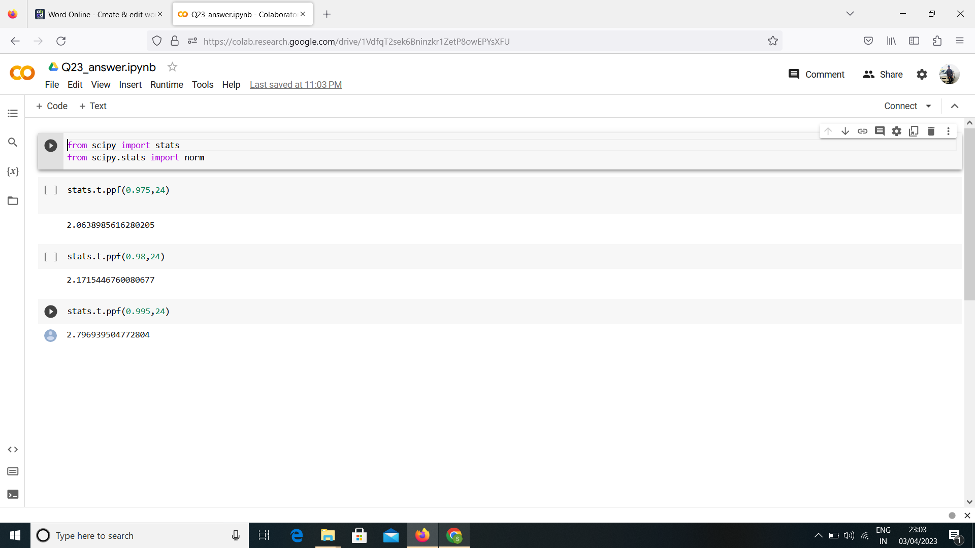

Q 24**)** A Government company claims that an average light bulb lasts 270 days. A researcher randomly selects 18 bulbs for testing. The sampled bulbs last an average of 260 days, with a standard deviation of 90 days. If the CEO's claim were true, what is the probability that 18 randomly selected bulbs would have an average life of no more than 260 days

Hint:

rcode à pt(tscore,df)

df à degrees of freedom

